BEST 15 FOODS TO CLEANSE YOUR LUNGS

**15. Garlic**

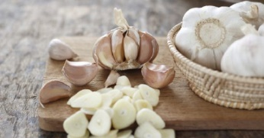

Garlic has numerous advantages and ways to improve your health. Besides being known for fighting infections and reducing inflammation it also reduces the risk of lung cancer.

14. Ginger

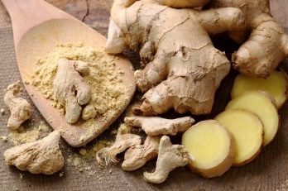

Thanks to its anti-inflammatory properties you can help to remove the toxins and clear your respiratory organ by adding ginger to dishes as a herb or drinking ginger root tea blended with some lemon.

13. Turmeric

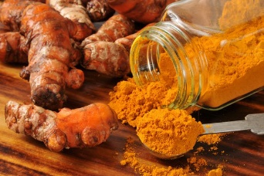

Turmeric is pretty similar to ginger and garlic according to their anti-inflammatory properties, so no surprise this spice is also great for your lungs.

12. Apple



Apples help to prevent the development of different lung diseases and to maintain a healthy respiratory system due to the various vitamins and flavonoids it contains.

11. Dark Berries

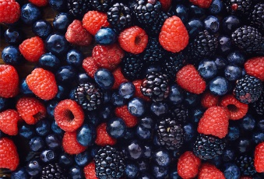

As is is widely known they are rich in antioxidants, so blackberries, blueberries and raspberries for instance reduce the risk of lung cancer as well as other infections and diseases.

10. Grapefruit



If your lungs have been affected by carcinogens, you should definitely eat some grapefruit. This fruit will help you cleanse your lungs since it contains a lot of lung supporting minerals and vitamins.

9. Pomegranate

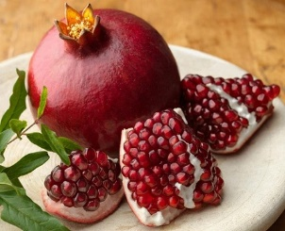

Pomegranate contains a lot of good properties. In fact, its juice has higher level of antioxidants than green tea or red wine so it can slow down and prevent the development of various lung diseases.

8. Seeds, nuts and beans

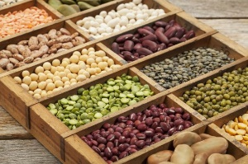

Foods that contain a lot of magnesium are highly recommended for asthmatic people because of their ability to help increasing the lung capacity and and improving the efficiency of the respiratory process.

7. Pistachio

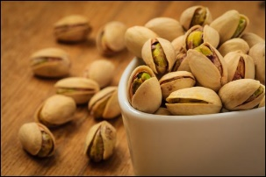

According to several studies, raw pistachios improve the health of your lungs and also help to lower the level of cholesterol in your body.

## 6. Cayenne pepper

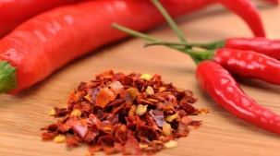

Whoever suffers from bronchial congestion or other respiratory problems should certainly consume some cayenne pepper, which suppresses coughs and sore throats as well.

5. Chili and curry



Try chili or curry if you feel the need to detoxify your lungs.They are so spicy that they essentially liquefy any mucus in your lungs, throat and nose.

4. Onions

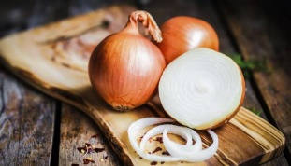

Everyone knows that onions have many health benefits. They are rich in folic acids, vitamin C and B6, which help fight against lung cancer.

3. Cruciferous vegetables

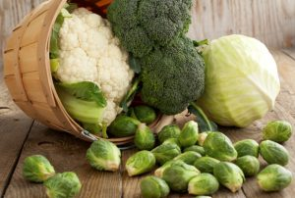

The cabbage family is just full of antioxidants. Broccoli and cauliflower for example are perfect to cleanse your body from toxins.

## 2. Foods with carotenoids

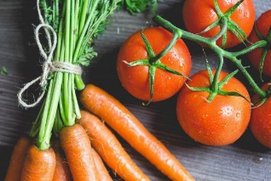

Carotenoids like tomatoes, carrots and apricots contain a special type of antioxidant which is converted in Vitamin A when consumed and this way they are highly effective against asthma.

1. Water



Sure, water is not food but it is really important to mention. It accelerates the detoxification process of your lungs so don’t forget to drink a lot!